TLG Windpower Products

www.tlgwindpower.com
Ph: (620) 422-3700
Fax: (620) 422-3702

The TLG-500 Wind Generator
For 12 & 24 volt systems
For those that know the best just isn’t good enough!

Brushless Design  Stainless Steel / Aluminum Construction  Real Output Power no B*S* ;)  Quiet Operation  (even in high winds)  Furls by Physics' not moving parts.  Unit weighs about 50 pound assembled  No planned maintenance  mount it and forget it  Easy to install  Proven results | 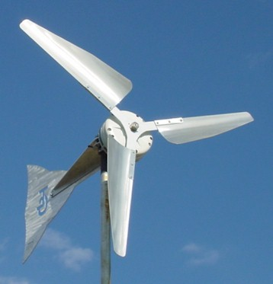  Delivers over 5Kw by industry standard rating! | Mounts on standard 1 1/2" guyed pipe  TLG-500 Generator Head  Yaw Assembly with Bearing  Boast Buster Rotor with Stainless Steel hub  3 phase Bridge Rectifier  All hardware necessary to assemble  Heavy Construction tested to 100 Mph  You supply the Tower and Wiring  Reaches full output at only 463 rpm's

The TLG-500 wind generator is designed to furl by physics rather than moving parts. This form of furling drastically reduces lateral thrust (wind loading) on your tower in the event of a storm or high winds. It also further protects the unit from over speeding, which could result in over heating of the head.

Owners are saying:  There is no doubt about the quality and durability in your product. You have put together the total package here. From the generator to the yaw bracket/mount to the blades. It all has quality and pride written all over it.  Dave Auto Climate Systems.  Thanks for making a real windmill for the little guy. After seeing it really work, I didn't mind at all spending money. This time I didn't get ripped off.  Randy from New York state.  This unit is very well built and a great value for the money. It’s a very good-looking unit and it puts out way more power than anything in its price range.  It was very simple to put together. Everything you said about it is true.  Mark Howland  Rudyard Auto Sales, Rudyard Michigan.  Many more at www.tlgwindpower.com | Output below is based on the information provided by several owners of the TLG-500 wind generator | Product Comparison  It is difficult to compare the 50-pound TLG-500 wind generator to other units on the market today since its unique design and heavy-duty construction places it in a class all of its own.  One common question is; “how does the TLG-500 compare to the popular AIR 403 in output?”  Output into a 12 volt battery bank  (Based on information provided by owners)  At 18 mph it would take approximately 8 - AIR 403 units to match the output of a single TLG-500
  Mph wind |  | Amps |  | Volts
  5 MPH | 1 Amp |  | 12 Volts
  8 MPH | 2.5 Amps |  | 12 Volts
  9 MPH | 3 Amps |  | 12 Volts
  11 MPH | 4 Amps |  | 12.5 Volts
  12 MPH | 5 Amps |  | 13 Volts
  18 MPH | 10 Amps |  | 13.5 Volts
  24 MPH | 15 Amps |  | 13.7 Volts
  28 MPH | 20 Amps |  | 14 Volts
  30 MPH | 25 Amps |  | 14.4 Volts
  34 MPH | 30 Amps |  | 14.7 Volts
  38 MPH | 35 Amps |  | 14.8 Volts
  45 MPH | 40 Amps |  | 14.8 Volts
  50 MPH | 50 Amps |  | 14.8 Volts
  AIR 403 |  | TLG-500
  Wind | Amps | Wind | Amps
  8 mph | N/A | 5 mph | 1
  10 mph | N/A | 8 mph | 2.5
  11 mph | N/A | 9 mph | 3
  12.5 mph | N/A | 11 mph | 4
  15 mph | N/A | 12 mph | 5
  18 mph | 1 | 16 mph | 8

